# SEAT BOOKING PORTAL

**BACKGROUND**: Employees are returning to the office as the government has lifted the WFH rules with the decrease in the number of COVID cases in India. Companies need to set up a system that would help the employees successfully book a seat/desk in the office for any day in advance and allow the company to keep track of the count of employees (WFH and WFO).

**PROBLEM STATEMENT**: To create a user-friendly tool accessible by all employees which would let them book a seat/desk in the office in advance for up to 5 working days.

## Sequence Diagram:

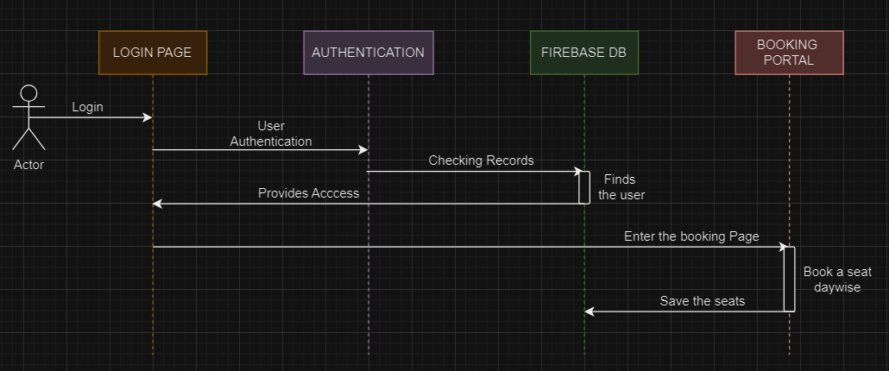

## Login Page:

* Features: Authenticating the Employee using the credentials (Phone Number, Email ID, and Password).
* Option to Choose & Upload RTPCR Test.

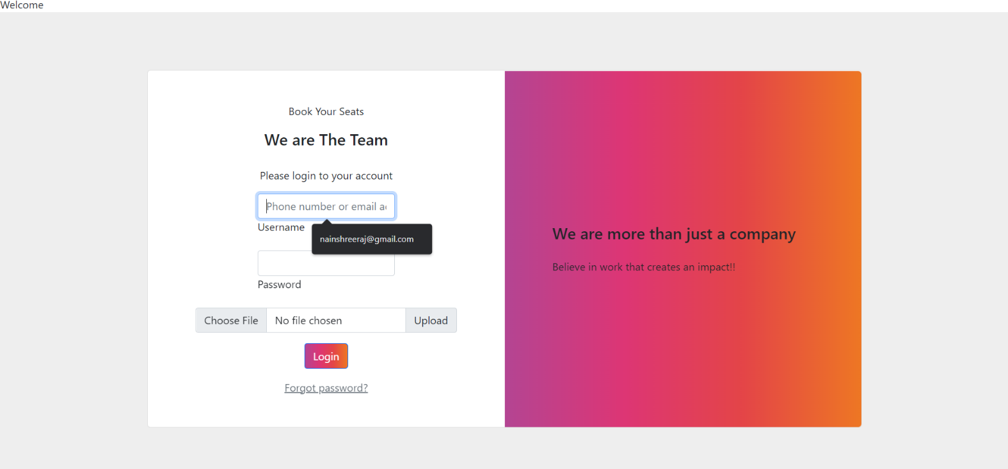

## Validating:

* Made use of the Firebase Database Services provided by Google.
* Stores the credentials of the Employee (Name, Email, and Password for Authentication and RTPCR reports).

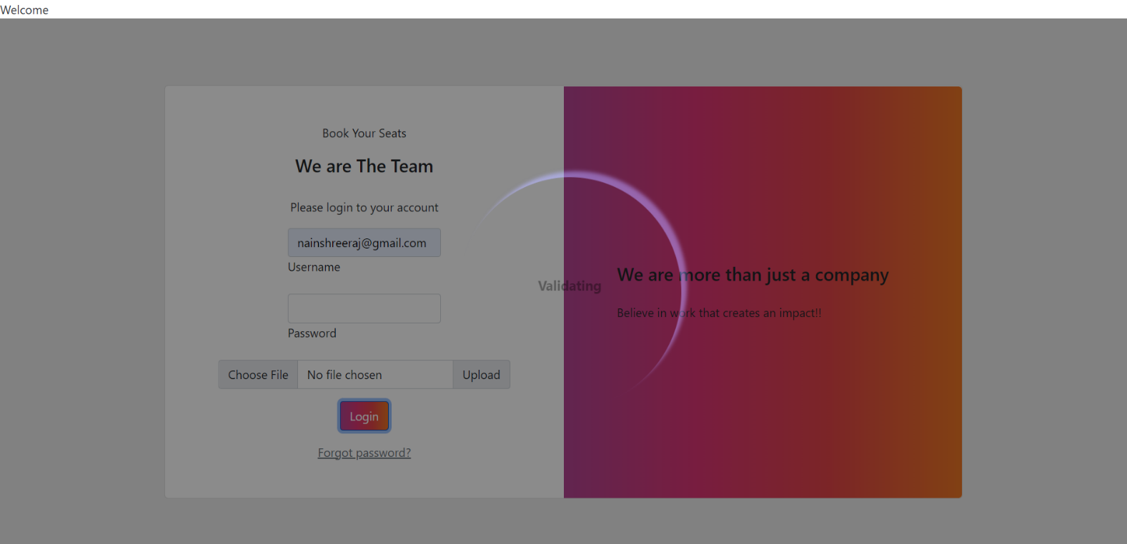

## Booking Portal:

* Created a navigation bar at the top, containing details about the employee trying to Log-In the System.
* Choose a Day (Mon /Tues /Wed /Thurs /Fri /Sat) to view available seats.
* Implemented a dynamically changing presentable format for the EMPTY, SELECTED, NOT SELECTED seats.
* Hovering feature to select a seat.
* Different colours to show empty, selected, and not selected seats.

